

Name: Maheen Tokir
Registration Number: FA23-BCS-041
Internship Organization: Askari bank (IT HUB)
Team: IT Operations Team
University Supervisor: Sir Mukhtiar Zamin
External Supervisor: Sir Kashif Siddique
Weekly Task: 4
Reporting Period: February 9, 2026 – February 13, 2026

Question:
A commercial bank operates multiple branches, each relying on critical IT infrastructure such as ATMs, servers, biometric systems, and networking devices. The IT department records complaints, downtime hours, maintenance schedules, and device age in spreadsheet files.
As an IT intern, you are required to propose a theoretical Microsoft Excel–based monitoring system to improve operational tracking and decision making.
Explain how Excel can be technically structured and utilized to:
- Design a centralized data management sheet for branch-wise IT records.
- Apply analytical functions (e.g., SUMIFS, COUNTIFS, IF with AND/OR logic, and date functions) for calculating downtime, complaint frequency, and maintenance overdue status.
- Classify IT assets into Low, Medium, and High risk categories based on predefined technical criteria.
- Use Pivot Tables generate summarized management reports.
- Enhance efficiency, reduce downtime, and support proactive IT infrastructure management in the banking environment..

ANSWER
In a multi-branch banking setup, IT infrastructure such as ATMs, servers, biometric devices and network switches plays a critical role in day to day operations. Monitoring these assets efficiently is essential to avoid downtime, service disruptions, and operational delays. Microsoft Excel can be effectively used as a theoretical tool to organize, analyze, and report IT operations data.

1. Centralized Data Organization
Excel allows creating a master sheet that consolidates all branch-level IT information. The dataset may include columns such as:
- Branch Name
- Device Type
- Device ID
- Complaint Status (Pending / Resolved / In Progress)
- Downtime Hours
- Last Maintenance Date
- Device Age
Centralizing this information helps IT teams access all relevant data in one place, making monitoring and reporting easier.

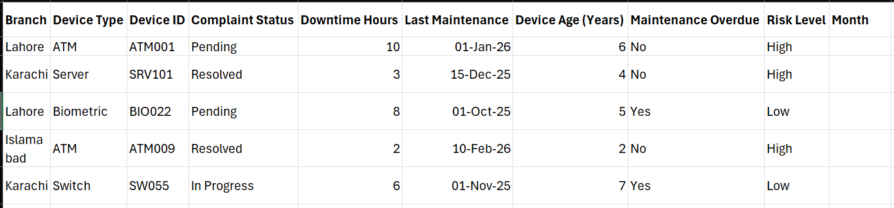
(Figure 1: Example dataset in excel)

2. Analytical Functions
Excel formulas are applied

- SUMIFS can calculate the total downtime for each branch or device type.
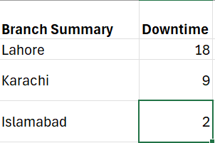
(Figure 2: This column uses SUMIFS)
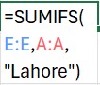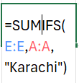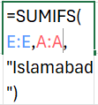
(Figure 3: Actual formulas used in the above 3 columns)

- COUNTIFS can count unresolved complaints or devices with overdue maintenance.
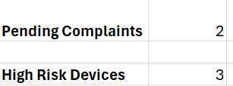
(Figure 4: These columns use COUNTIFS formula)


(Figure 5: Actual formulas used in the above columns)

- IF combined with AND/OR can assign risk categories based on multiple conditions such as device age, downtime, or complaint status.
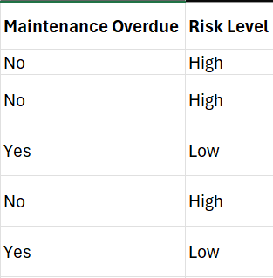
(Figure 6: These columns use combinations of IF and AND/OR operator)
(Figure 7: Formulas used in Maintenance column)

(Figure 8: Formulas used in Risk Level column)

- DATE and TODAY functions can automatically flag devices with overdue maintenance schedules.
(Figure 9: Using the TODAY() function to calculate the maintenance overdue for each bank)

These functions allow for systematic evaluation without manually reviewing large datasets.

3. Risk Classification
Using logical formulas and conditional formatting, devices can be categorized as:
- High Risk: Devices with frequent downtime, pending complaints, or overdue maintenance.
- Medium Risk: Devices with moderate downtime or slightly delayed maintenance.
- Low Risk: Devices operate normally with up-to-date maintenance.
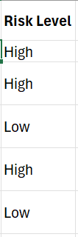
(Figure 10: Risk Level Column)

4. Pivot Tables
Pivot Tables can summarize data efficiently, providing:
- Total downtime per branch
- Number of complaints per device type
- Distribution of devices by risk level
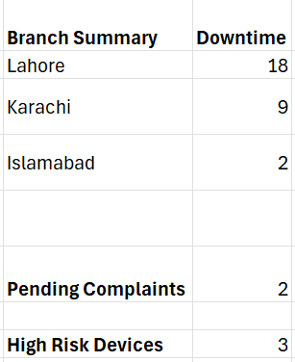
(Figure 11: Pivot tables that use formulas mentioned in Figure 3)

5. Decision Support and Operational Benefits
An Excel-based IT monitoring system offers multiple advantages:
- Proactive identification of failing or high-risk devices
- Faster resolution of IT complaints
- Branch-wise comparison of infrastructure performance
- Planning for preventive maintenance and replacement
- Data-driven insights for management decision-making

Conclusion
Even without specialized software, Microsoft Excel can serve as an effective tool for IT operations monitoring in banks. By combining centralized data, analytical formulas, conditional formatting, Pivot Tables Excel can classify risks, track performance, and support strategic decision-making. This ensures operational efficiency, reduces downtime, and improves the overall reliability of IT infrastructure across branches.

